The meeting "Under the framework of "Belt And Road", Jiangsu - St. Petersburg Science & technology innovation cooperation " has been successfully held on-line 16th June 2020!

General information about the meeting

Bilateral (China-Russia) on-line meeting on the theme of "Promoting science, technology and innovation cooperation on regional level between Jiangsu province (China) and St.Petersburg (Russia)”, was initiated by The General Consulate in St.-Petersburg, St.-Petersburg research center of the Russian academy of sciences (SPBRC RAS) and Jiangsu Industrial Technology research institute (JITRI). The most important North-West Russian districts, namely St. Petersburg City, Leningrad region and Kaliningrad region – all situated on the territories adjacent to the Baltic sea, were selected for co-operation (this region thereafter is referred to as the St.-Petersburg).

The meeting was aimed to generally set up the international (bilateral) Working Group for deployment the regional co-operation in fundamental and applied science, technologies and innovations between Jiangsu region and St-Petersburg; selection of models for this co-operation at it’s the first phase and then; choosing appropriate scientific and technical fields for cooperation; suggestions about preparation of proposals for one or more projects following JITRI’s “financial pool model”. These project(s) will serve as initial step, as a trial for joint performance and subsequent further development of cooperation.

The meeting where speakers from both sides presented their opinions and suggestions, supported with presentations, has been held under the framework of “Belt and Road“ program as well as under initiative "Sino-Russian year of scientific and technological innovation”. It has achieved all its aims.

This meeting crowns intensive and relatively long-lasting preparations, such as visit of Consul of Science and Technology, Zhao Wei to SPBRC RAS when the parties have decided to start the cooperation with establishment of working group; correspondence between Zhao Wei, JITRI and SPBRC RAS: two local meetings in SPBRC RAS with potential participants of cooperation from Russian institutes (SPBRC RAS, IGGP RAS, JSC «Vedeneev VNIIG»), representing fundamental and applied sciences.

Participants and talks

Representatives of government agencies attending and providing speeches at this meeting were: Wang Wenli, General Consul, Zhao Wei, Consul of Science and Technology of The General Consulate of People’s Republic of China in St. Petersburg, Russia and Li Xuqin, researcher of the Foreign Cooperation Department of the Department of Science and Technology of Jiangsu province. The JITRI was represented by the Secretary of the Party Committee Hu Yidong and representatives of the Ministry of Overseas Cooperation.
Russian side (Figure) speakers were Orlova Marina Ivanovna, Interim the Chairman of the SPBRC RAS, Kuznetzov Anton Borisovich, fellow member of the Russian academy of sciences, the Director of the Institute of Geology and Geochronology of Precambrian of the Russia academy of sciences (IGGP RAS), Tzarovtzeva Inga Maratovna, the Head of laboratory of the JSC «Vedeneev VNIIG», belonging to “RusHydro” company.

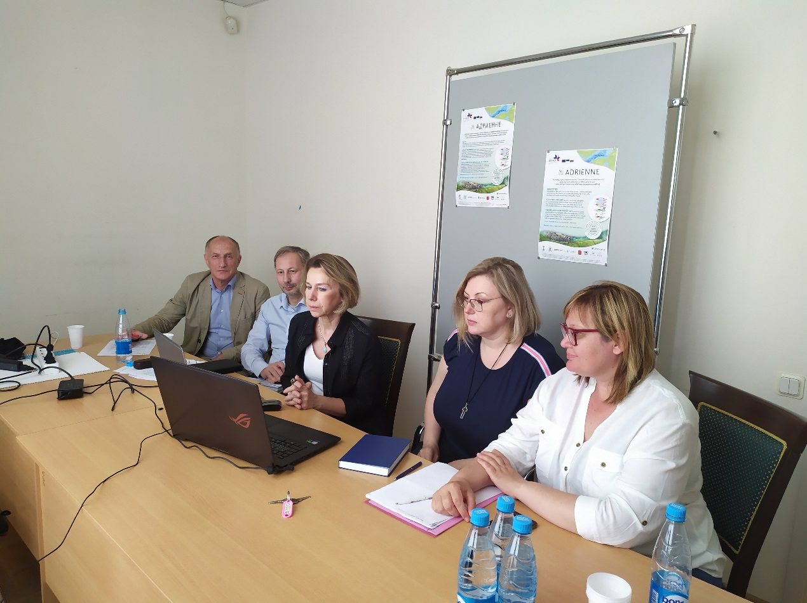
Figure. Russian participants in SPBRC RAS meeting room – D.K. Donskoy, A.B. Kuznetzov, M.I. Orlova, A.M. Majorova, I.M. Tzarovtzeva.

At the meeting, Consul General Wang Wenli first made a speech: "Science and technology cooperation is an important part of Sino-Russian strategic cooperation. This year is the "Sino-Russian year of scientific and technological innovation". Under this background, the significance of holding the first scientific and technological innovation exchange meeting is particularly important. Hope Jiangsu Industrial Technology Research Institute and the San Science Center make use of their respective advantages, to exchange and learn from each other, and contribute to the pragmatic cooperation and development of the two countries."
Secretary Hu thanked Consul General Wang Wenli for her care and support for the cooperation between JITRI and the SPBRC RAS, and her trust and encouragement of our province’s Science and Technology Department for our institute’s cooperation with Russia; then he introduced the basic information of Jiangsu Province and Jiangsu Industrial Technology Research Institute, the cooperation model of JITRI, as well as the opinions on the establishment of technology and innovation cooperation between Jiangsu and St. Petersburg, at the same time, he proposed the establishment of the "Jiangsu-St. Petersburg Science, Technology and Innovation Cooperation" working team to provide an efficient, pragmatic and convenient platform for future cooperation between the two regions.
Orlova Marina Ivanova Interim the Chairman of the SPBRC RAS put forward ideas on the regional situation in St. Petersburg and possibilities of scientific and practical cooperation specific to problems of this industrial region, she also presented experience of participating the research institutes of St.-Petersburg in long-lasting international cooperation in the Baltic Sea region in the frame of “neighborhood” models working there during the last decade and getting together diverse project to start with concrete scientific research and to end with “Big Investment Projects”. In the Baltic Sea region, possible directions and fields of co-operation could be “Materials and Environment”, “Nature protection” first, she also mentioned such directions as biomedical sciences, telecommunications and transport. She outlined aims, tasks and structure for the Working Group and perspectives of its development together with establishment of cooperation. Initial working team for the establishment of the "Jiangsu-St. Petersburg Science, Technology and Innovation Cooperation" is already set up and includes representatives of Russian institutions participating in the meeting as well as the Institute of Oceanography of the Russian Academy of Sciences. The coordinating center for the Russian side of group will be SPBRC RAS.

Members of the Russian team, Kuznetzov Anton Borisovich, and Tzarovtzeva Inga Maratovna had short talks about their institutes representing Russian fundamental and applied science.

Outputs of the meeting
In the end, both parties agreed to establish and improve the personnel and tasks of the "Jiangsu-St. Petersburg Science and Technology and Innovation Cooperation" working team, with the goal of promoting the “Jiangsu-St. Petersburg Science and Technology and Innovation Cooperation”, with the cooperation in the fields of materials, energy and environmental protection as the starting point. Utilize JITRI’s international cooperation funding pool, joint doctoral training projects, and joint application for Sino-Russian intergovernmental industrial cooperation/fund projects to explore the potential for cooperation between the two sides, to promote and deepen the content of cooperation between the two sides, and to realize the industrialization of technology.
Investigator Li Xuqin commented: "This meeting is a good start for the cooperation between Jiangsu Industrial Technology Research Institute and SPBRC. I hope that the cooperation between the two parties will bring the cooperation between Jiangsu and St. Petersburg to a higher level of regional scientific and technological innovation."

